**Flexi Date Range Picker**

**Description**

Flexi Date range picker is an input widget which is able to take a range of dates input from user, It has enhanced User Interface with easy start date and end date selection. It comes with a single view calendar which makes it convenient even for smaller screens.

**Typical usage scenario**

It is used for taking input of a range of dates from user or if there is need to put validation on user range selection.

**PreRequisites**

NA

**Features and Limitations**

* Select a range of dates.
* Easy to update selection.
* Set custom maximum and minimum date.
* Dynamic maximum and minimum date.
* Set default date selection.
* Set minimum detail of calendar up to century.
* Able to show validation message like text box.

**Screenshots**

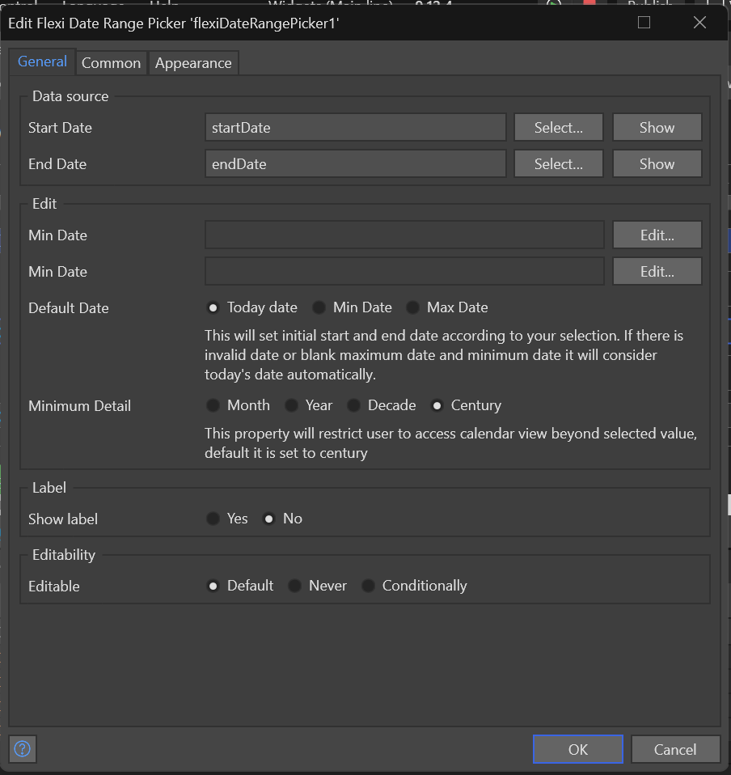

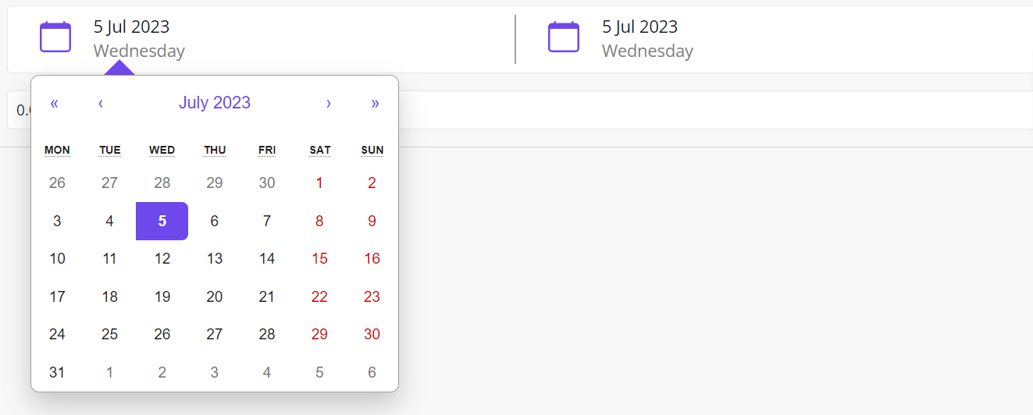

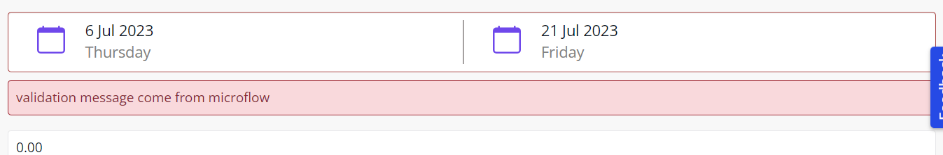

**Dependencies**

* Require Mendix 9.12.4 or above.

**Installation**

1. Download it from the marketplace in your application.
2. Drag it from tools and drop inside data view.
3. Right click on widget open properties then select start and end date attributes at data source section.
4. From the general section, you can select some optional properties for widget.

**Min Date –** By setting this property dates before min date are disabled from calendar view.

**Max Date –** By setting this property dates after max date is disabled from calendar view.

**Minimum Detail –** By setting this property user has view access up to the selected view by default it is at century.

**Default Date –** By setting this property user will see this date selected on calendar until and unless user not select dates.

**Configuration: NA**

**Category: Widget**

**Subcategory: All**

**Visibility: Public Marketplace**

**Studio Pro Version: 9.12.4**